**INTERNET OF THINGS LAB RECORD**



|  |  |
| --- | --- |
| **Name:** | Ishan Kumar |
| **Registration Number:** | FET-BAML-2022-2026-012 |
| **Course:** | Btech CSE AIML |
| **Semester:** | 5th |
| **Faculty:** | Mr. Biswajeeban Mishra &  Mr. Pritam Nanda |

|  |  |
| --- | --- |
| **Remarks** |  |
| **Signature** |  |

**Index**

|  |  |  |  |  |
| --- | --- | --- | --- | --- |
| **Sl. No.** | **Date** | **Experiment/Case Study** | **Page No.** | **Remark** |
| **1** | 9-8-2024 | Blinking of Internal LED on Arduino board |  |  |
| **2** | 9-8-2024 | Blinking an External LED |  |  |
| **3** | 9-8-2024 | Read Humidity and Temperature value using DHT22 |  |  |
| **4** |  | A case study on  a communication Protocol: MQTT |  |  |
| **5** |  | Building a web app using Node-Red to fetch DHT sensor data and display it on the web app dashboard |  |  |
| **6** |  | Working with button, LED Interfacing Ultrasonic Sensor |  |  |
| **7** |  | Use of Breadboard |  |  |
| **8** |  |  |  |  |
| **9** |  |  |  |  |
| **10** |  |  |  |  |

***Experiment 1: Date:9-8-24***

**Aim of the experiment:** Blink Inbuilt Led of your Arduino Board

**Requirements:** Arduino UNO board ,USB cable ,Computer with Arduino IDE installed

**Description:** Arduino boards come with a built-in LED connected to digital pin 13. This LED can be controlled through programming to turn it ON and OFF, which creates a blinking effect. We use digitalWrite() function to control the LED state and delay() function to create time intervals between states and the variales high and low represent the the voltage when the led turns on and off.

**Procedure:**

1. Connect your Arduino board to the computer using the USB cable.
2. Open the Arduino IDE on your computer.
3. Create a new sketch and type the following code:

**Code:**

void set(){

pinMode(LED_BUILTIN, OUTPUT);

}

void loop() {

digitalWrite(LED_BUILTIN, HIGH);

delay(1000);

digitalWrite(LED_BUILTIN, LOW);

delay(1000);

}

1. On the above click on Tools menu and select:

* The correct board (Arduino UNO)

1. Click the Upload button (arrow icon) to upload the code to your Arduino.

**Observations**: We can observe that the built-in LED on your Arduino board start blinking with a 1-second interval.

**Conclusion**: Through this experiment we demonstrated how setup() and loop() function work and the usage of digitalWrite() and delay() functions.And how we can control the digital outputs timing sequence.

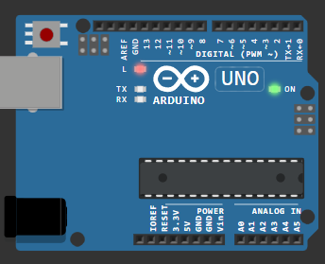

***Experiment 2: Date:9-8-24***

**Aim of the experiment:** To control an external LED with Arduino board, making it blink at regular intervals.

**Requirements:** Arduino UNO board , USB cable, External LED,Two wires,Computer with Arduino IDE installed

**Description:** In this experiment an external LED is connected to a digital pin of the Arduino, and the program will make the LED blink at regular intervals.Also demonstrates Arduino's ability to control external hardware. By making an LED blink through programmed commands.

**Procedure:**

1. Connect your Arduino board to the computer using the USB cable.
2. Connect the longer leg (anode) of the LED to pin 8 on the Arduino.
3. Connect the shorter leg (cathode to the ground (GND) of the Arduino.
4. Open the Arduino IDE on your computer.
5. Create a new sketch and type the following code:

**Code:**

int ledPin = 8;

void setup() {

pinMode(ledPin, OUTPUT);

}

void loop() {

digitalWrite(ledPin, HIGH);

delay(1000);

digitalWrite(ledPin, LOW);

delay(1000);

}

1. Select Arduino UNO from Tools → Board menu
2. Click upload button

**Observations**: We can observe that the external LED start blinking with a 1-second interval.

**Conclusion:** Through this experiment we understood the concept of controlling the external LED with the Arduino board.And how to establish the connections between the resistors ,pins and the LEDs.

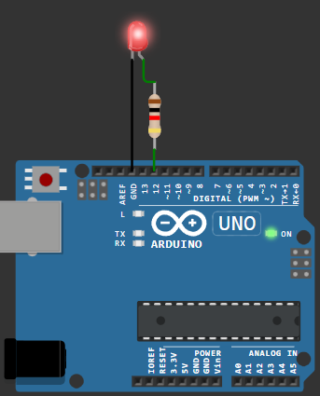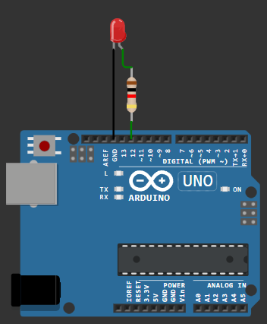

***Experiment 3: Date:9-8-24***

**Aim of the experiment:** Measuring temperature and pressure using DHT sensor

**Requirements:** Arduino UNO board , USB cable, External LED,Two wires,Computer with Arduino IDE installed

**Description:** The DHT22 sensor is a basic digital temperature and humidity sensor. It uses a capacitive humidity sensor and a thermistor to measure the surrounding air, and sends a digital signal to display on serial monitor..

**Procedure:**

1. Connect your Arduino board to the computer using the USB cable.
2. Connect the VCC pin of the DHT22 sensor to the 5V pin on the Arduino.
3. Connect the GND pin to the ground (GND) of the Arduino.
4. Connect the data pin to pin 2 on the Arduino.
5. Open the Arduino IDE on your computer.
6. Install DHT library (Sketch → Include Library → Manage Libraries)
7. Search for DHT sensor library by Adafruit and install it
8. Create a new sketch and type the following code:

**Code:**

#include DHT.h

#define DHTPIN 2

#define DHTTYPE DHT22

DHT dht(DHTPIN, DHTTYPE);

void setup() {

Serial.begin(9600);

dht.begin();

}

void loop() {

delay(2000);

float humidity = dht.readHumidity();

float temperature = dht.readTemperature();

if (isnan(humidity) || isnan(temperature)) {

Serial.println(Failed to read from DHT sensor!);

return;

}

Serial.print(Humidity: );

Serial.print(humidity);

Serial.print( %\t);

Serial.print(Temperature: );

Serial.print(temperature);

Serial.println( °C);

}

**Observations**: The DHT sensor provides continuous monitoring of environmental conditions, updating both temperature and humidity readings every two seconds. Temperature values are shown in Celsius, while humidity readings are displayed as percentages

**Conclusion:** In this experiment, we successfully interfaced the DHT22 sensor with the Arduino to measure humidity and temperature. This data was displayed on the serial monitor. The DHT library simplifies sensor interaction, allowing us to focus on gathering and displaying environmental data. This experiment is useful for weather-related projects or environmental monitoring systems. We also learn to use external libraries, making it a perfect introduction to Arduino-based environmental monitoring projects.



***Experiment 4: Date:9-8-24***

**Aim of the experiment:** A case study on  a communication Protocol: MQTT

**Description:** MQTT is like a messaging system designed specifically for Internet of Things (IoT) devices. Think of it as a postal service for smart devices. Mainly it has 3 components. They are Broker, Subscriber, Publisher. These 3 play a vital role in the communication.

In this experiment we are going to configure the MQTT in our local Machine.

**Procedure:**

**In SystemOS [ Windows11 ]:**

* Installed Mosquitto as a Service from Official Eclipse Page [ https://mosquitto.org/download/ ].
* This allows the MQTT Broker to run automatically in the background.
* Added mosquittio.exe to the System Environment Variables PATH [ ' C:\Program Files\mosquitto ' ], which allows us to use MQTT commands directly in the Command Prompt or, Terminal.
  + Starting @ boot byDefault:
  + net start mosquitto
  + Stopping:
  + In Elevated CMD > net stop mosquitto
  + For Transmission: Navigate to [ cd C:/Program Files/mosquitto ]
  + mosquitto.exe -v
    - // -v is a Verbose Output flag, that enables us to see the backend processes, log messages, that'd help us to debug whenever necessary.

**In Linux [WSL: Ubuntu 22.04 LTS]:**

* In Terminal > wsl --install -d Ubuntu-22.04 > \ E / N \ T / E \ R /
* Restart the machine, and Launch Ubuntu 22.04
* $sudo apt update
* $sudo apt install mosquitto mosquitto-clients
* Starting mosquitto services:
* $sudo systemctl ( enable /start ) mosquitto
* Mosquitto Broker Service Status can be checked here:
* $sudo systemctl status mosquitto
* Once verified service status, transmission can be carried on.
* Stopping mosquitto services:
* $sudo systemctl stop mosquitto

**Practical implementation**:

**Testing MQTT Services [ Message Transmission: WinOS11 + Ubuntu 22.04 ]:**

* - Open 2 Terminals:
* 1st: mosquitto_sub.exe -h localhost -t test/topic
* 2nd: mosquitto_pub.exe -h localhost -t test/topic -m Light was here!

**Conclusion:** Through this experiment we got an idea how mosquito protocol really works. And understood how to perform those activities.

Server side:

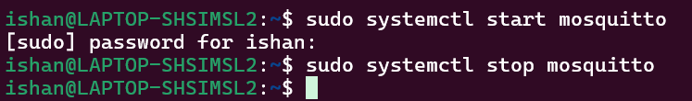

Subscriber:

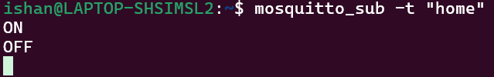

Publisher:

***Experiment 5: Date:9-8-24***

**Aim of the experiment:** Building a web app using Node-Red to fetch DHT sensor data and display it on the web app dashboard

**Requirements:** Node.js platform,NodeRED

**Procedure:**

**Install Node.js:**

* Installed NodeJS from Official Eclipse Page [ https://nodejs.org/en/download/package-manager ].
* Added node.js to the System Environment Variables PATH [ ' C:\Users\Hi\AppData\Roaming\npm ' ], which allows us to use npm commands directly in the Command Prompt or, Terminal.

**Installing & Initialising NodeRED:**

- Open Node.js > npm install node-red-dashboard

- [PostInstallation] > Elevated CMD: node-red

In Client Application, browsed localhost:1880 [ Accessing NodeRED ]

- Inside the NodeRED window, a flow was created w/ the nodes as:

> SERIAL-IN ( Arduino Uno R3 Board )

> DEBUGGER

> DHT FUNCTION

> 2 GAUGES ( Humidity & Temperature )

- Serial In Node: Configured it to read from the correct serial port where my Arduino is connected (e.g., COM11) > Set the baud rate to 9600.

- Configure the DHT Function as:

var m = msg.payload.split(',');

if (m.length === 2) {

var H = { payload: parseFloat(m[0]) };

var T = { payload: parseFloat(m[1]) };

return [H, T];

} else {

return null;

}

- Adjusting Gauge Nodes:

> Humidity:

- Title as Humidity.

- Value format as `{{value}}%`.

- Minimum value to 0 and the maximum to 100.

> Temperatue:

- Title as ' Temperature '

- Value format as {{value}}°C.

- Ensure that Humidity & Temperature are in the same group.

**Deployment**:

- Uploaded DHT11 /22 Sketch to the Arduino Board through its IDE:

#include <DHT.h>

#define DHTPIN 3

#define DHTTYPE DHT11

DHT dht(DHTPIN, DHTTYPE);

void setup() {

Serial.begin(9600);

dht.begin();

}

void loop() {

float H = dht.readHumidity();

float T = dht.readTemperature();

if (isnan(H) || isnan(T)) {

Serial.println(Failed to read from DHT sensor!);

} else {

Serial.println(String(H) + , + String(T));

}

delay(2000);

}

- After uploading this sketch, close the IDE.

- Deploy the flow in NodeRED.

- Check the Dashboard in the upper-right corner, for the Humidity and Temperature Gauge.

***Experiment 6: Date:9-8-24***

**Aim of the experiment:** Interfacing Ultrasonic Sensorand working with LED

**Requirements:** Arduino UNO, USB cable, External LED,Two jumper wires,Computer with Arduino IDE installed

**Procedure:**

**1.Button: Held or, Released?**

Step#1: Connect 2 jumper wires *diagonally* to the Button.

Step#2: One wire to Digital Pin [ *here, 2* ], and the other wire to GND.

Step#3: After configuring the Arduino UNO R3, this sketch is to be uploaded and executed in the IDE:

Step#4: Create a new sketch and type the following code:

**Code:**

const int buttonPin = 2;

void setup() {

Serial.begin(115200);

pinMode(buttonPin, INPUT_PULLUP);

}

void loop() {

int buttonState = digitalRead(buttonPin);

if (buttonState == LOW) {

Serial.println(Button Held!);

}

else {

Serial.println(Button Released!);

}

delay(500);

}

Output: Button Held! ; Button Released

**2.UltraSonic [ HC-SR04 ]: Measures Distance**

Step#1: Connect 4 jumper wires to the UltraSonic Sensor as [VCC: 5v], [Trigger: 9], [Echo: 8], & **GND**.

Step#2: After configuring the **HC-SR04** w/ **UNO R3**, this sketch is to be uploaded and executed in the IDE:

#define PIN_TRIG 9

#define PIN_ECHO 8

void setup() {

Serial.begin(9600);

pinMode(PIN_TRIG, OUTPUT);

pinMode(PIN_ECHO, INPUT);

}

void loop() {

digitalWrite(PIN_TRIG, HIGH);

delayMicroseconds(10);

digitalWrite(PIN_TRIG, LOW);

int duration = pulseIn(PIN_ECHO, HIGH);

Serial.print(Distance in CM: );

Serial.println(duration / 58

Serial.print(Distance in inches: );

Serial.println(duration / 148);

delay(1000);

}

**Output:**Distance in CM: 121 ; Distance in inches: 47

**3.HC-SR04 + PushButton**

Step#3: Now, a button can be connected to Digital 2 and diagonally to **GND**.

Step#4: After configuring the Button & the sensor, this sketch is to be uploaded and executed in the IDE:

#define PIN_TRIG 9

#define PIN_ECHO 8

#define buttonPin 2

void setup() {

Serial.begin(9600);

pinMode(PIN_TRIG, OUTPUT);

pinMode(PIN_ECHO, INPUT);

pinMode(buttonPin, INPUT_PULLUP);

}

void loop() {

int buttonState = digitalRead(buttonPin);

if (buttonState == LOW) {

digitalWrite(PIN_TRIG, HIGH);

delayMicroseconds(10);

digitalWrite(PIN_TRIG, LOW);

int duration = pulseIn(PIN_ECHO, HIGH);

Serial.print(Distance in CM: );

Serial.println(duration / 58);

Serial.print(Distance in Inches: );

Serial.println(duration / 148);

} else {

Serial.println(Button Released!);

}

delay(500);

}

**Output:**Button Released! ... ; Distance in CM: 24 ; Distance in Inches: 9

**4.Combining PushButton + UltraSonic Sensor + External LED + DHT Sensor**

Step#1: Get 9 Jumper wires [ M2F ], and connect them as:

* HC-SR04:
  + Trigger [ *Digital 9* ]
  + Echo [ *Digital 8* ]
  + VCC [ *5v* ]
  + GND
* DHT 11:
  + VCC [ *3.3v* ]
  + Data [ *Digital 4* ]
  + GND
* Button:
  + Corner 1 [ *Digital 2* ]
  + Diagonal Corner 4 [ GND ]
* External LED:
  + Anode [ +ve, *Digital 13* ]
  + Cathode [ -ve, GND]

Step#2: After configuring the entire Arduino Uno R3 with proper wire connections, the following could be executed in the IDE:

#include <DHT.h>

#define DHTPIN 4

#define DHTTYPE DHT11

#define PIN_TRIG 9

#define PIN_ECHO 8

#define BUTTON_PIN 2

#define LED_PIN 13

DHT dht(DHTPIN, DHTTYPE);

void setup() {

Serial.begin(9600);

dht.begin();

pinMode(PIN_TRIG, OUTPUT);

pinMode(PIN_ECHO, INPUT);

pinMode(BUTTON_PIN, INPUT_PULLUP);

pinMode(LED_PIN, OUTPUT);

}

void loop() {

int buttonState = digitalRead(BUTTON_PIN);

if (buttonState == LOW) {

digitalWrite(PIN_TRIG, HIGH);

delayMicroseconds(10);

digitalWrite(PIN_TRIG, LOW);

int duration = pulseIn(PIN_ECHO, HIGH);

float distanceCm = duration / 58.0:

Serial.print(Distance in CM: );

Serial.println(distanceCm);

if (distanceCm < 20) {

digitalWrite(LED_PIN, HIGH);

} else {

digitalWrite(LED_PIN, LOW);

}

float humidity = dht.readHumidity();

float temperature = dht.readTemperature();

if (isnan(humidity) || isnan(temperature)) {

Serial.println(Failed to read from DHT sensor!);

} else {

Serial.print(Humidity: );

Serial.print(humidity);

Serial.print( %\t);

Serial.print(Temperature: );

Serial.print(temperature);

Serial.println( *C);

}

} else {

Serial.println(Button Released!);

}

delay(1500);

}

**Output:**Button Released!; Distance in CM: 18.45 -- Humidity: 79.00 % -- Temperature: 30.80 *C [ LED TURNED ON ] ; Distance in CM: 24.28 -- Humidity: 65.00 % -- Temperature: 30.80 *C [ LED TURNED OFF ] ; Button Released!

**Conclusion:** Through this experiment we understood the concept of working with button, LED and Ultrasonic sensor.

**Output Images:**

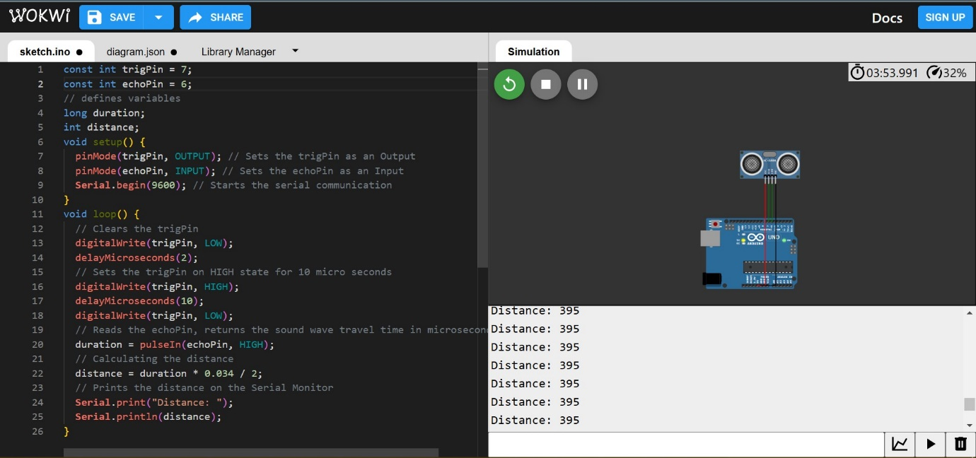

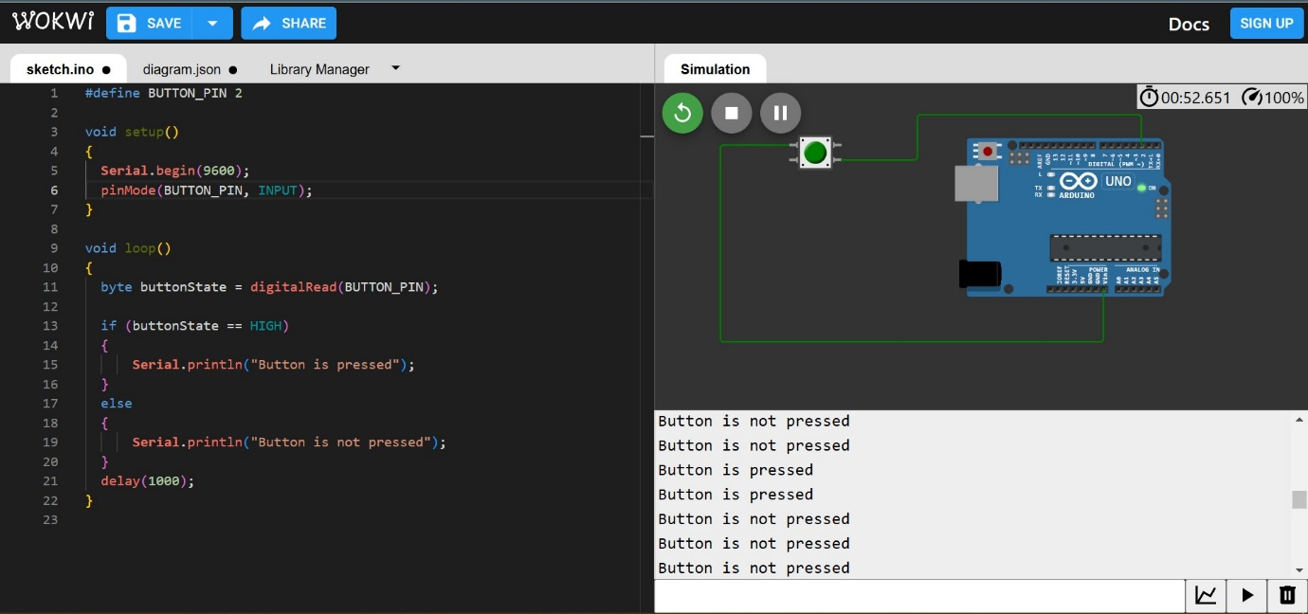

***Experiment 7: Date:9-8-24***

**Aim of the experiment:** Setting UpESPressif32 DevKit v1 [ NodeMCU: MicroController Unit ]

**Requirements:** Arduino IDE, USB cable.

**Procedure:**

**Setting Up ESPressif32**

Step#1: Inside Arduino IDE, Navigate to Files > Preferences > Additional Boards Manager URL > <https://dl.espressif.com/dl/package_esp32_index.json> < *paste this and click OK*

Step#2: Then head into BOARDS MANAGER > and Install esp32 by ESPressif Systems.

Step#3: Now, for establishing the connection, we would need to configure our mainframe w/ the CP210x USB-to-UART Bridge Virtual COM Port (VCP) Driver avaliable at [CP210x USBtoUART Driver](https://www.silabs.com/documents/public/software/CP210x_Windows_Drivers.zip).

Step#4: After a superfluous reboot, the mainframe is ready to be used w/ an ESPressif32, as in the Arduino IDE, we first select the correct COM port (*here, COM12*), and ESP32 Dev Module as the board.

* NOTE: While executing a sketch, the Board reuires to be in DOWNLOAD MODE /BOOT MODE, so for, the BOOT button is to be pressed while uploading the code onto the board, exactly post Connecting... for 3-4 seconds.
  + A simple way around for this redundancy, would be:
    - Holding the BOOT button (GPIO0), the EN (Enable Pin) button is pressed for a second.
    - Post releasing the EN button, finally, the BOOT button is let go.
  + *This would keep the Espressif32 in the bootloader mode, so it could be equipped w/ any further sketch executions.*

Step#5: To blink the internal LED, the following is to be executed in the IDE:

**Code:**

// Define LED pin

#define LED_PIN 2

void setup() {

pinMode(LED_PIN, OUTPUT);

}

void loop() {

digitalWrite(LED_PIN, HIGH);

delay(1000);

digitalWrite(LED_PIN, LOW);

delay(1000);

}

**Output**: Internal LED (blue) blinks @ 1s duration

**Configuring the ESPressif to SCAN Wireless-Fidelity Signals!**

Step#6: The ESP32 can be used to scan nearby Wi-Fi signals using the following sketch:

#include WiFi.h

void setup() {

Serial.begin(115200);

WiFi.mode(WIFI_STA);

WiFi.disconnect();

delay(100);

Serial.println(Setup done);

}

void loop() {

Serial.println(Scan start);

int n = WiFi.scanNetworks();

Serial.println(Scan done);

if (n == 0) {

Serial.println(no networks found);

} else {

Serial.print(n);

Serial.println( networks found);

Serial.println(Nr | SSID | RSSI | CH | Encryption);

for (int i = 0; i < n; ++i) {

// Print SSID and RSSI for each network found

Serial.printf(%2d, i + 1);

Serial.print( | );

Serial.printf(%-32.32s, WiFi.SSID(i).c_str());

Serial.print( | );

Serial.printf(%4ld, WiFi.RSSI(i));

Serial.print( | );

Serial.printf(%2ld, WiFi.channel(i));

Serial.print( | );

switch (WiFi.encryptionType(i)) {

case WIFI_AUTH_OPEN: Serial.print(open); break;

case WIFI_AUTH_WEP: Serial.print(WEP); break;

case WIFI_AUTH_WPA_PSK: Serial.print(WPA); break;

case WIFI_AUTH_WPA2_PSK: Serial.print(WPA2); break;

case WIFI_AUTH_WPA_WPA2_PSK: Serial.print(WPA+WPA2); break;

case WIFI_AUTH_WPA2_ENTERPRISE: Serial.print(WPA2-EAP); break;

case WIFI_AUTH_WPA3_PSK: Serial.print(WPA3); break;

case WIFI_AUTH_WPA2_WPA3_PSK: Serial.print(WPA2+WPA3); break;

case WIFI_AUTH_WAPI_PSK: Serial.print(WAPI); break;

default: Serial.print(unknown);

}

Serial.println();

delay(10);

}

}

Serial.println();

WiFi.scanDelete();

delay(5000);

}

**Output: *n Networks Found! ; Light's Space Stone ; Airtel77***

**Conclusion:** Through this experiment we understood how to work with ESP32 and blink the internal LED ,Configuring ESPressif to scan wireless signals.